

SCHOOL OF COMPUTER SCIENCE AND ENGINEERING

A COURSE BASED REPORT (IOT and Applications)
ON
“SMART PLANT MONITORING SYSTEM USING NODE MCU”
Submitted in fulfillment of the requirements for the award of the Degree of

BACHELOR OF TECHNOLOGY
IN
COMPUTER SCIENCE AND ENGINEERING (IOT AND CYBERSECURITY INCLUDING BLOCK CHAIN TECHNOLOGY) (2023 - 2027)

Submitted by

Ashik Hebbar K V (R23EI008)
Abhishek Prabha (R23EI001)
Amith D P (R23EI004)
Prajay S Patil (R23EI030)

Under the guidance of
Dr. Manjula R. Bharamagoudra
Professor, School of ECE
REVA University

June 2024
Rukmini Knowledge Park, Kattigenahalli, Yelahanka, Bengaluru-560064
www.reva.edu.in

DECLARATION

We, Ashik Hebbar K V (R23EI008), Abhishek Prabha(R23EI001), Amith D P(R23EI004), Prajay S Patil (R23EI030) students of B.Tech, belongs to School of Computer Science Engineering,(School Name) REVA University, declare that this IOT Report “Smart Plant Monitoring system using NODE MCU” is the result of work done by us under the supervision of Dr. Manjula R.B, Professor(Theory taking faculty) School of ECE REVA University, Bengaluru.

We are submitting this Report in partial fulfillment of the requirements for the completion of Course in IOT and Applications in II-Semester of Bachelor of Technology in Computer Science and Engineering by the REVA University, Bengaluru during the academic year 2023-2024.

(Signature of the Students)

June 2024

Certified that this work submitted by Mr. Ashik Hebbar K V (R23EI008) ,Abhishek Prabha (R23EI001), Amith D P (R23EI004), Prajay S Patil(R23EI030) has been carried out under our guidance and the declaration made by the candidates is true to the best of our knowledge.

Signature of Faculty Signature of Director
Date: June 2024 Date: June 2024
Official Seal of the School

Name of the Examiner with affiliation Signature with Date
1.
2.

ACKNOWLEDGEMENTS

We extend our deepest gratitude to our esteemed guide, Dr. Manjula R. Bharamagoudra, Professor, School of Electronics and Communication Engineering whose expert guidance and unwavering support have been pivotal to our project's success.
We wish to express our deepest gratitude to Prof. Raghavendra Reddy, our year-wise coordinator and class teacher Dr.Anil Ambore. who has been instrumental throughout the entirety of the academic cycle.
We are deeply grateful to the Head of Department, Dr. N P Nethravathi, for inspirational guidance and encouragement.
Our sincere gratitude to Dr. Ashwinkumar U M, Director, School of CSE and Dr. K.M. Sudharshan, Director School of ECE for fostering an atmosphere conducive to our scholarly accomplishments. Our sincere gratitude to Dr. K S Narayana Swamy, Registrar for the support.
We also express our gratitude to Dr. R.C. Biradar, Pro-Vice Chancellor (Administration), Dr. Sanjay Chitnis, Pro-Vice Chancellor (Dept. of Administration) and Dr. Shubha A, Pro - Vice Chancellor (Academics, Governance, Training and Placement) for their strategic vision and administrative support that have significantly enriched our academic experience.
We are indebted to Dr. N Ramesh, Vice Chancellor (I/C), for his exemplary administrative support and steadfast commitment to educational excellence.
We are immensely grateful to Dr. P. Shyama Raju, Chancellor, for his visionary leadership and relentless pursuit of creating an enriching learning atmosphere.
Finally, we extend our gratitude to the technical and non-technical staff of school of ECE, whose dedication and hard work behind the scenes have been fundamental to our project's success and our daily academic operations.

ABSTRACT
In recent years, there has been a significant surge in interest towards smart systems utilizing Internet of Things (IoT) technology for monitoring and managing various aspects of daily life. One such area is smart agriculture, where IoT can revolutionize traditional farming practices. This project focuses on the development of a Smart Plant Monitoring System using Node MCU, an IoT platform that integrates a microcontroller with Wi-Fi capabilities.
The primary objective of this project is to create an automated system capable of monitoring and controlling environmental variables crucial for plant growth, such as soil moisture, temperature, and humidity. The Node MCU serves as the core component responsible for data acquisition from various sensors deployed in the plant environment. These sensors include moisture sensors to measure soil moisture levels, temperature sensors for monitoring ambient temperature, and humidity sensors for assessing surrounding humidity.
Data collected by the sensors are processed locally on the Node MCU and transmitted wirelessly to a cloud platform for storage and further analysis. The cloud platform plays a pivotal role in enabling remote access to real-time and historical data, facilitating informed decision-making by users, such as farmers or gardeners. Additionally, the system incorporates actuators controlled by the Node MCU to automate actions based on the collected data, such as activating irrigation systems when soil moisture levels drop below a certain threshold.
The implementation of this Smart Plant Monitoring System offers several advantages over conventional methods. It provides real-time monitoring, enhances resource management by optimizing water and energy usage, and enables proactive responses to environmental changes that impact plant health. Moreover, the system promotes sustainability in agriculture by reducing wastage and improving overall efficiency.
In conclusion, the integration of Node MCU and IoT technologies in the development of the Smart Plant Monitoring System demonstrates a practical application of IoT in agriculture, showcasing its potential to transform traditional farming practices into more efficient and sustainable methods. This project serves as a stepping stone towards realizing smart agriculture solutions that can meet the challenges of modern-day agricultural needs.

TABLE OF CONTENTS

List Of Contents |  | Page. No
Abstract |  | 4
Chapter-1 | 1.1 Introduction | 6
 | 1.2 Objective | 7
 | 1.3 Applications | 7-8
Chapter-2 | Literature Survey | 8-10
Chapter-3 | 3.1 Methodology | 11
 | 3.2 Block Diagram | 12
 | 3.3 Circuit Diagram | 13
 | 3.4 Components Required | 13
 | 3.5 Algorithm | 14
Chapter-4 | 4.1 Procedure | 15-18
 | 4.2 Result and Analysis | 19-21
 | 4.3 Conclusion | 21
 | 4.4 Future Scope | 22-23
References |  | 24

CHAPTER-1
1.1 Introduction
In today's fast-paced world, maintaining healthy plants can be a challenge. Busy schedules and forgetfulness can lead to underwatering or overwatering, ultimately harming our precious greenery. This is where the concept of a smart plant monitoring system using NodeMCU for IoT (Internet of Things) comes in, offering a technological solution for nurturing your plants with intelligence.
This project introduces a user-friendly system built around the NodeMCU microcontroller. This powerful yet affordable device acts as the brain of the operation, collecting data from various sensors about your plant's environment. Imagine tiny eyes monitoring the soil moisture, temperature, and humidity – all feeding valuable information to the NodeMCU.
The magic doesn't stop there. Equipped with Wi-Fi capabilities, the NodeMCU transmits this sensor data wirelessly to a designated platform, such as a mobile app or web dashboard. This allows you to access real-time insights into your plant's well-being from anywhere with an internet connection.
But the true beauty lies in the actionable results. By analysing the data, the system can send alerts when critical thresholds are reached. For example, imagine receiving a notification on your phone when the soil becomes dry, prompting you to give your plant a much-needed drink.
This project goes beyond mere monitoring. In some configurations, the system can even be programmed to trigger automated actions. Think of a water pump automatically activating based on soil moisture readings, ensuring your plant receives the perfect amount of hydration without human intervention.
With a smart plant monitoring system using NodeMCU, you're essentially creating a personalized assistant for your plants. It empowers you to become a more informed and proactive caretaker, ultimately fostering a thriving green haven in your home or garden.

1.2 Objective:
The main objective of a smart plant monitoring system using NodeMCU is to create an automated and data-driven approach to plant care. This system aims to:
* Optimize plant growth by monitoring and regulating environmental factors.
* Conserve water by providing targeted irrigation based on real-time data.
* Allow remote monitoring of plant health for informed decision-making.
1.3 Applications:
Home and Balcony Gardens:
- Urban Gardening: These systems empower city dwellers with limited outdoor space to effectively manage their balcony or indoor gardens. Real-time data allows for adjustments to lighting, watering, and temperature, fostering healthy plant growth in confined environments.
- Herb Gardens: Precise monitoring of factors like humidity and light becomes crucial for successfully cultivating delicate herbs indoors. Automated watering based on soil moisture ensures optimal conditions for consistent harvests.
Precision Agriculture:
- Greenhouses and Controlled Environments: Large-scale farms and greenhouses can leverage these systems to optimize growing conditions for specific crops. Sensor data can be used to regulate temperature, humidity, and irrigation across vast areas, maximizing yield and resource efficiency.
- Remote Field Monitoring: Farmers can monitor soil moisture and other environmental factors in remote fields, enabling informed decisions about irrigation and resource allocation. This is particularly beneficial for managing large farms or fields in geographically diverse locations.

Research and Education:
- Academic Research: Researchers can utilize these systems to collect real-time data on plant responses to various environmental stimuli. This data can be invaluable for studying plant physiology, the impact of climate change, or developing new agricultural techniques.
- Educational Tools: These systems can be integrated into educational settings to teach students about plant science and the importance of environmental monitoring. Students can use the system to observe plant growth patterns and gain hands-on experience with data collection and analysis.
Specialized Applications:
- Hydroponics: These systems are ideal for monitoring nutrient levels and pH in hydroponic setups, ensuring optimal growth conditions for plants cultivated without soil.
- Bonsai Care: The meticulous care required for bonsai trees can be significantly aided by real-time monitoring of factors like moisture and temperature, helping enthusiasts maintain the health of their miniature trees.
Chapter–2: Literature Survey
1. Introduction
The integration of Internet of Things (IoT) technologies in agriculture, often referred to as smart agriculture or precision farming, has gained considerable attention in recent years. These technologies hold the potential to revolutionize traditional farming practices by enabling real-time monitoring, data-driven decision-making, and resource optimization. Among the IoT platforms used for smart agriculture applications, Node MCU stands out due to its affordability, versatility, and capability to integrate seamlessly with various sensors and actuators.

2. IoT Applications in Agriculture
IoT-based solutions in agriculture encompass a wide range of applications aimed at enhancing crop productivity, improving resource efficiency, and mitigating environmental impact. According to Lloret et al. (2016), IoT-enabled smart farming systems leverage sensors to monitor parameters such as soil moisture, temperature, humidity, and light intensity. Node MCU, based on the ESP8266 microcontroller, has been extensively utilized in these systems for its ability to connect sensors and actuators wirelessly, facilitating real-time data collection and control.
3. Sensor Integration
Critical to the functionality of smart plant monitoring systems is the integration of sensors tailored to agricultural environments. Mirás-Avalos et al. (2019) highlight the importance of sensor accuracy and reliability in obtaining precise data on soil conditions and plant health. Commonly integrated sensors include soil moisture sensors, which provide insights into soil water content crucial for irrigation management, and temperature sensors for monitoring ambient conditions affecting plant growth. The Node MCU platform supports the integration of these sensors through its GPIO pins and ADC channels, enabling seamless data acquisition and transmission.
4. Data Processing and Analysis
In smart plant monitoring systems, Node MCU plays a pivotal role not only in data acquisition but also in local data processing and transmission to cloud-based platforms for further analysis. Gope et al. (2017) discuss the significance of data analytics techniques such as machine learning algorithms in interpreting sensor data to derive actionable insights. These insights enable farmers and agricultural practitioners to make informed decisions regarding irrigation scheduling, fertilizer application, and pest management, thereby optimizing resource use and improving crop yield.
5. Remote Monitoring and Control
One of the key advantages of Node MCU-based smart plant monitoring systems is their ability to enable remote monitoring and control of agricultural operations. Zoha et al. (2018) emphasize the deployment of actuators controlled via IoT platforms to automate irrigation systems based on real-time sensor data. This capability not only enhances operational efficiency but also reduces labor costs and conserves water resources by ensuring timely and precise irrigation practices.
6. Case Studies and Applications
Several case studies demonstrate the practical implementation and benefits of Node MCU IoT projects in agriculture. Bailey et al. (2020) provide insights into IoT-enabled smart greenhouse systems, where Node MCU facilitates climate monitoring and control to create optimal growing conditions for greenhouse crops. Such applications illustrate the scalability and adaptability of IoT technologies in diverse agricultural settings, from large-scale farms to urban gardens.
7. Challenges and Future Directions
Despite the advancements, smart plant monitoring systems using Node MCU and IoT face challenges that require further research and innovation. Karim et al. (2021) identify challenges such as power management for IoT devices, data security and privacy concerns, and the need for interoperability standards among sensors and communication protocols. Future research directions include enhancing sensor network robustness, developing energy-efficient IoT solutions, and integrating advanced analytics for autonomous decision-making in agriculture.
8. Conclusion
In conclusion, the literature survey highlights the transformative potential of Node MCU and IoT technologies in smart plant monitoring systems. By addressing technical challenges and exploring innovative applications, researchers aim to enhance agricultural sustainability, productivity, and resilience in the face of global food security challenges. The integration of Node MCU facilitates real-time monitoring, data-driven decision-making, and resource optimization, positioning IoT as a catalyst for modernizing agriculture towards more efficient and sustainable practices.

Chapter-3: Methodology, Block Diagram, Circuit Diagram, Components, Algorithm
3.1 Methodology
* Hardware Selection:
* NodeMCU microcontroller board
* Sensors (soil moisture sensor, temperature & humidity sensor)
* Relay module (for automated irrigation)
* Power source (battery or USB)
* Sensor Integration:
* Connect sensors to the NodeMCU board based on pin configurations.
* Programming the NodeMCU:
* Write code (using Arduino IDE) to:
* Read sensor data
* Process and format the data
* Connect to a Wi-Fi network
* Transmit data to an IoT platform (e.g., Blynk)
* IoT Platform Integration:
* Set up an account on an IoT platform.
* Create a dashboard to visualize sensor data.
* System Calibration:
* Test the system and adjust sensor thresholds for optimal plant care.

3.2 Block Diagram:
There are usually several components working together to form a Smart Plant Monitoring System monitor and optimize the health of plants. This simplified explanation of the Block Diagram is given below. Sensors: These are the primary input devices that gather data about the plant’s environment. Temperature, humidity, soil moisture sensors are included. NODE MCU ESP8266: This component processes the data received from the sensors. Communication module: The communication WIFI module which is embedded in node mcu allows the system to be connected to other devices or on the Internet. Data storage: It is common to store sensor data for analysis or historical reference purposes. This is in the form of a cloud-based system. This all is depicted in the figure3.2.

CLOUD APP

TEMPERATURE SENSOR

MOISTURE SENSOR NODE MCU ESP-8266 POWER SUPPLY

POWER SUPPLY WATER PUMP RELAY

Figure:3.2

3.3 Circuit Diagram:
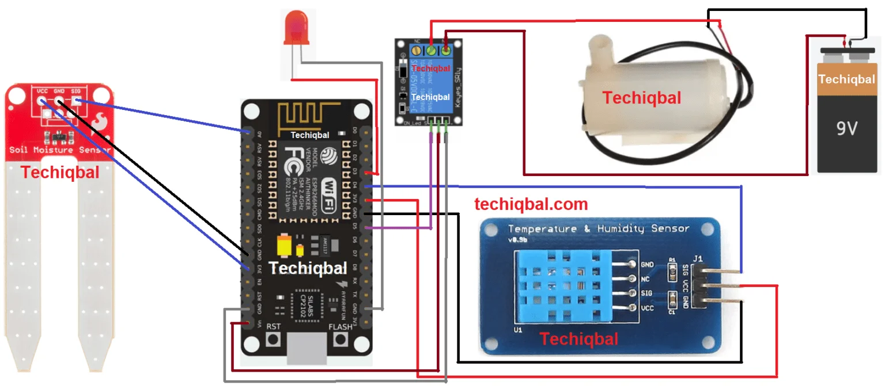
Figure 3.3
3.4 Components Required:

- Node MCU ESP8266
- Moisture Sensor
- Relay Module
- DHT11 Temperature and Humidity Sensor
- Water Pump
- Power Supply Battery
- Connecting Wires
- Tray
- Plant

3.5 Algorithm:
- Initialization and Setup:
  - Define the necessary libraries and include headers for OneWire, SPI, Blynk, DHT (humidity and temperature sensor), and DallasTemperature (temperature sensor).
  - Set up the pins for the OneWire bus (D2) and the DHT sensor (DHTPIN = 2).
  - Initialize the DHT sensor and set the type to DHT11.
  - Set up the water pump control pin (waterPump = D5) and initialize the relay state (Relay = 0).
- Sensor Data Collection:
  - In the sendSensor () function:
    - Read humidity and temperature data from the DHT sensor.
    - If the readings are valid, send the values to Blynk (virtual pins V5 for humidity and V6 for temperature).
- Soil Moisture Sensing:
  - In the sendTemps () function:
    - Read analog data from pin A0 (connected to a soil moisture sensor).
    - Map the sensor reading to a moisture percentage (output) based on the sensor’s characteristics.
    - Request temperature data from the DallasTemperature sensor.
    - Send the temperature (V1) and moisture percentage (V2) to Blynk.
- Water Pump Control:
  - The BLYNK_WRITE(V12) function handles the relay control:
    - When the virtual pin V12 is updated (e.g., from the Blynk app), set the relay state accordingly.
    - If the relay state is 1, turn on the water pump (LOW); otherwise, turn it off (HIGH).
- Main Loop:
  - Run Blynk and the timer for data updates (Blynk.run () and timer.run () ).
  - Continuously collect and send sensor data.

CHAPTER-4 Procedure, Result and Analysis
4.1 Procedure:
Step-1: Connect moisture sensor to A0,3V and GND pin of Node MCU as shown in Figure 3.3.
Step-2: Connect the Temperature and humidity sensor to D4,3V and GND pin of Node MCU as shown in Figure 3.3.
Step-3: Connect the positive of the battery and Water Pump with the transistor and capacitor and join to D5 pin of Node MCU as shown in figure 3.3.
Step-4: Setup the Blynk App for Plant Monitoring system as given below
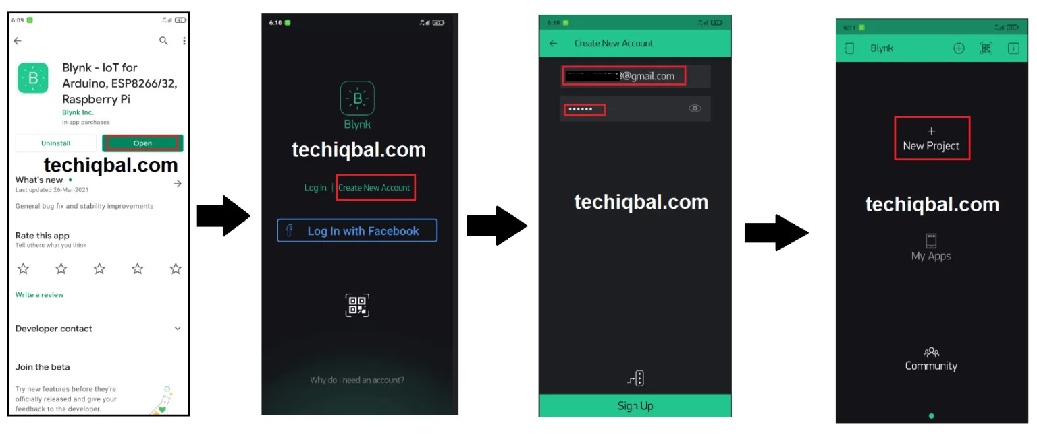
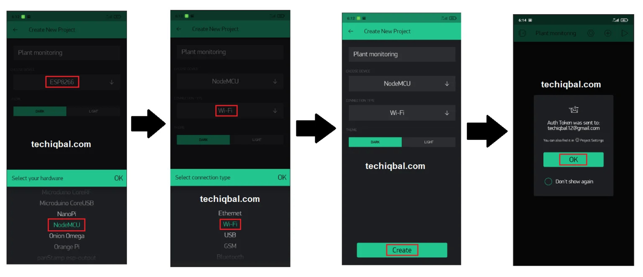
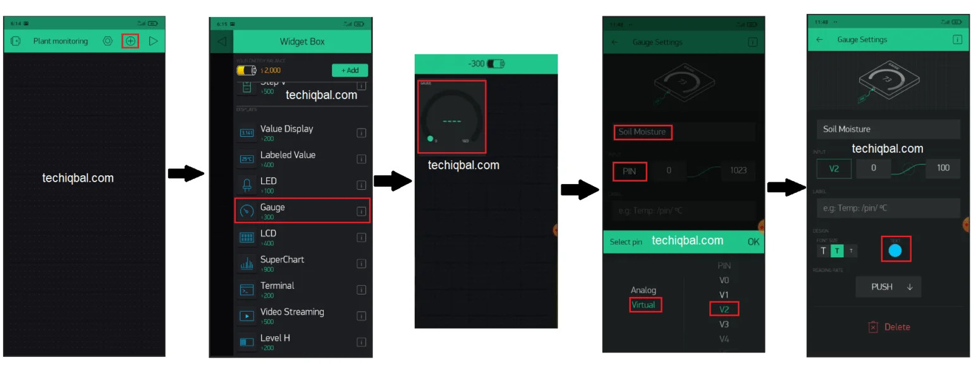
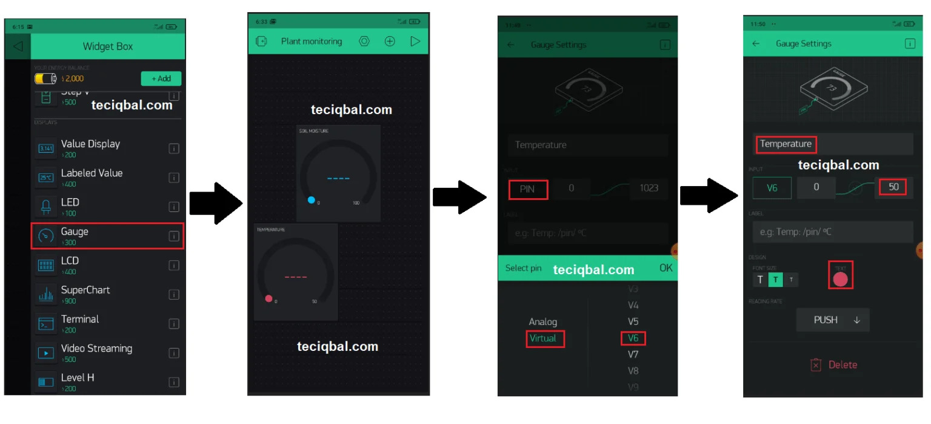
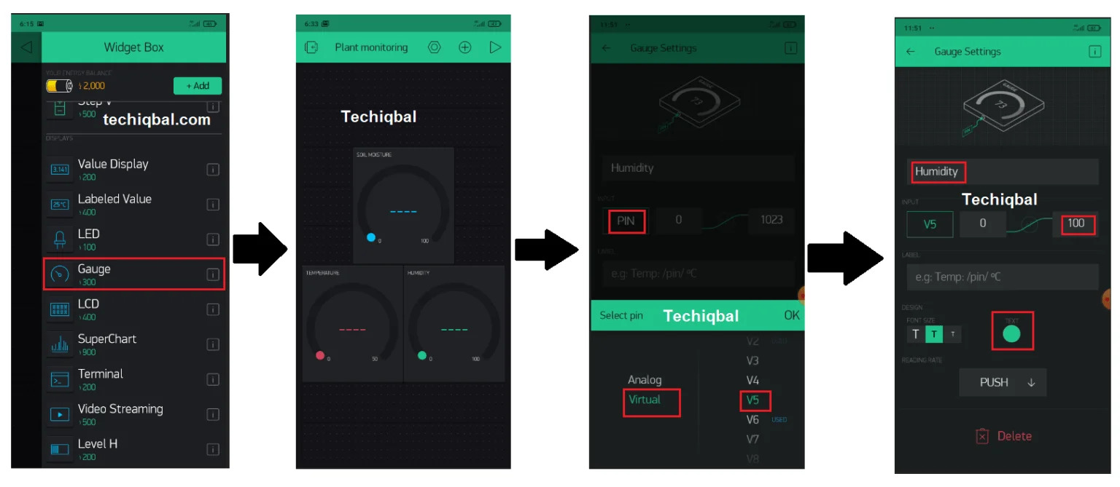
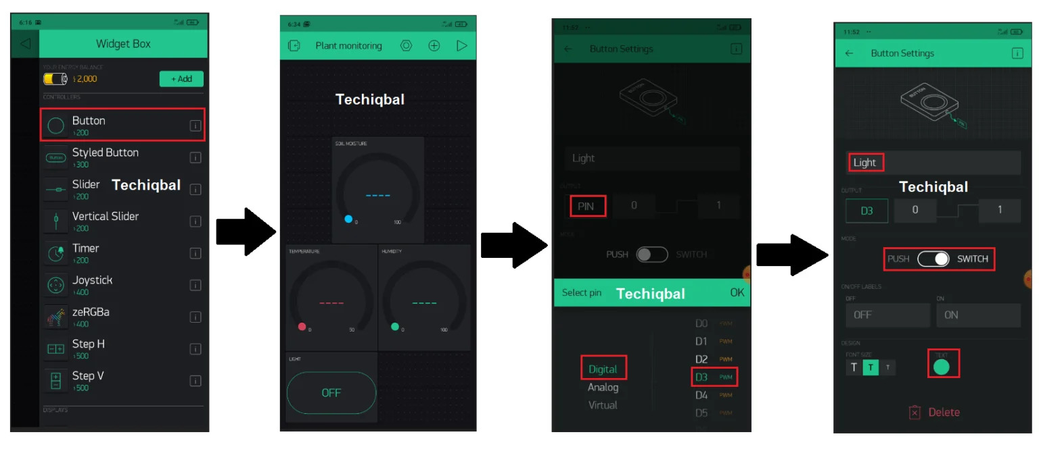
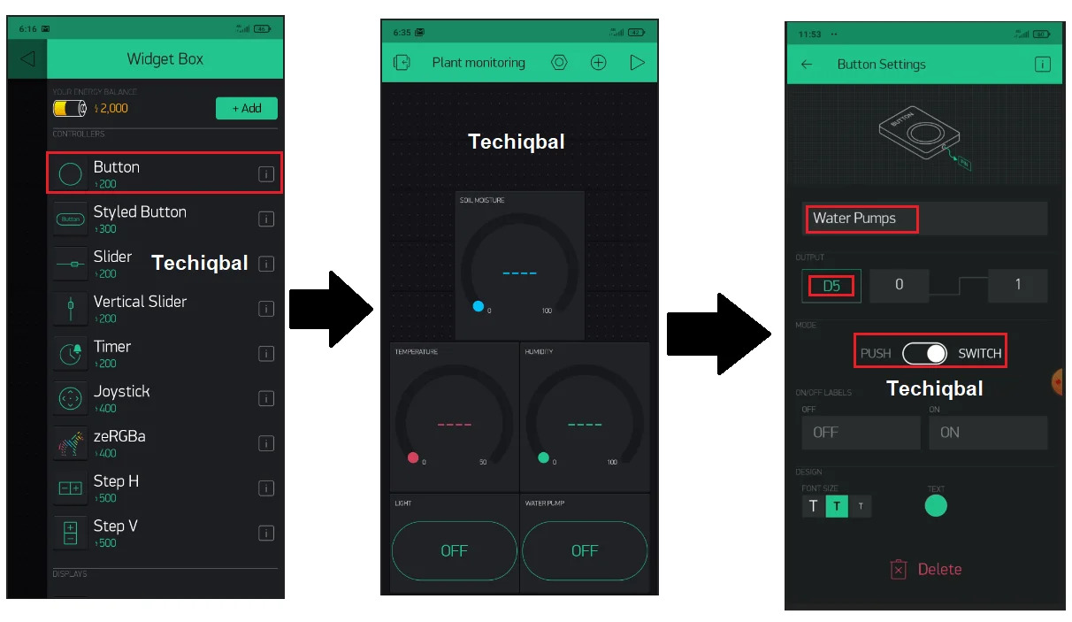
Step:5 Open the Arduino IDE Software and copy the code from the following link
Project Code Link: https://drive.google.com/file/d/1Q_GZppJ-WV_dNGAYu-JMvGj_mxv4pReP/view?usp=sharing

Step-6: Change the following in the code according to your device
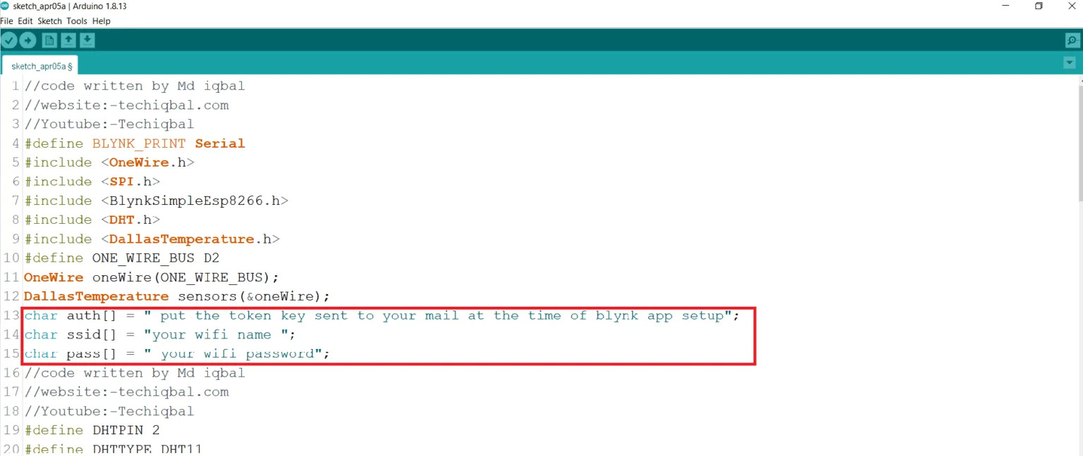
Step-6: Go to tools and select the appropriate Node MCU board
Step-7: Compile and upload the code to Node MCU
4.2 Result and Analysis
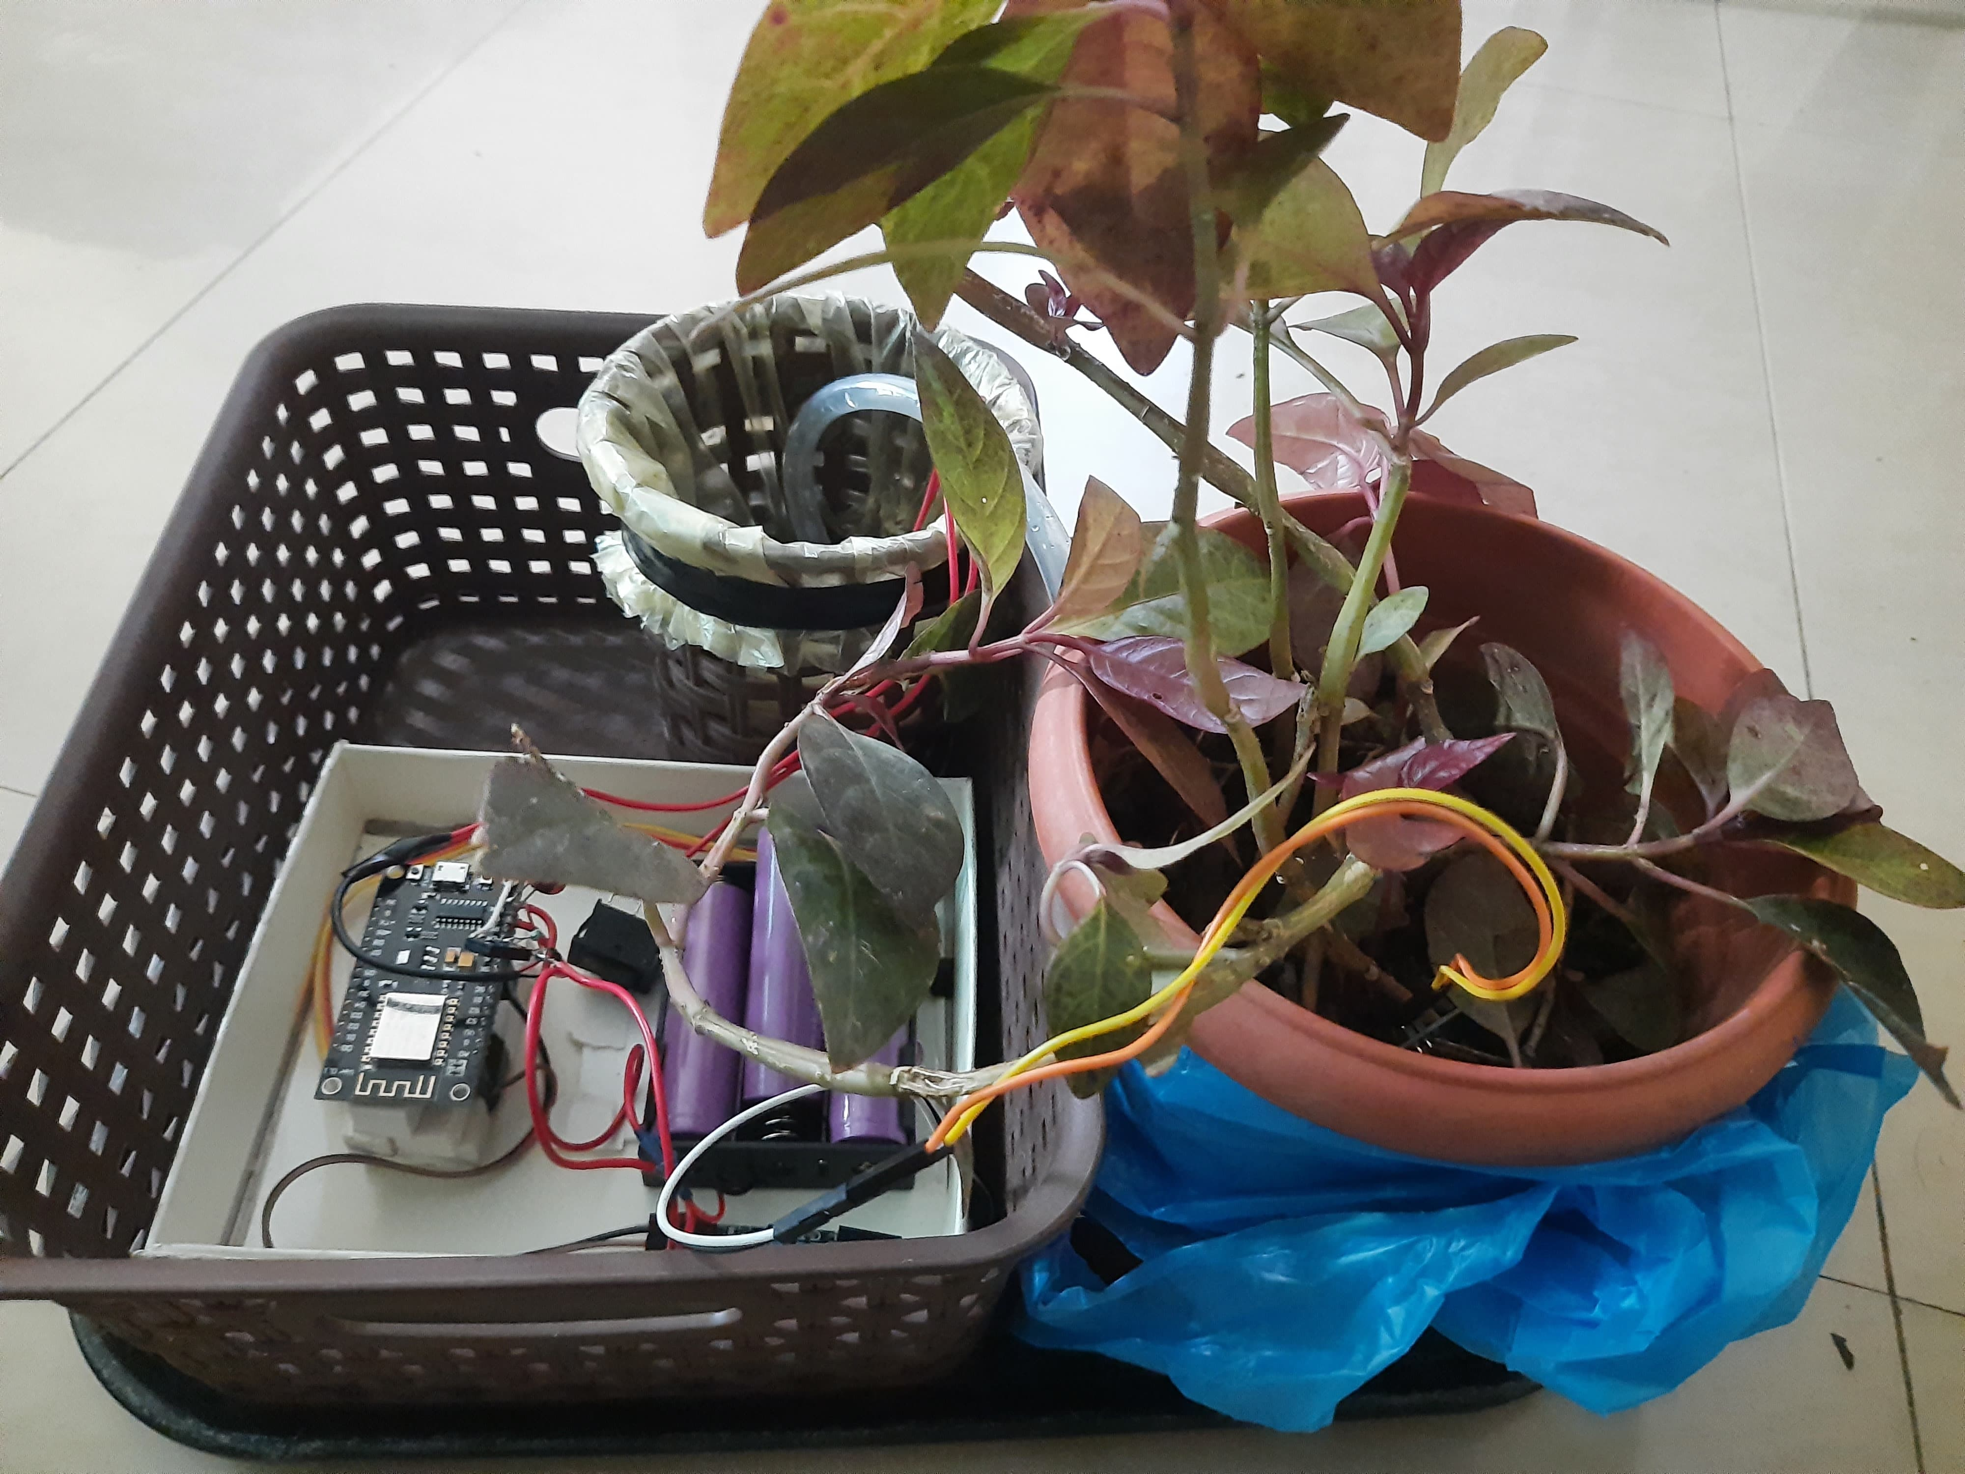
Figure 4.2
A smart plant monitoring system using NodeMCU offers several key results that benefit plant care and user experience.The pictorial representation of the working model is shown in Fig 4.2
The key results that benefit plant care and user experience are:
- Real-time Insights: The system continuously collects data on factors like soil moisture, temperature, and humidity, providing users with a real-time understanding of their plant's environment.
- Historical Data Tracking: Sensor readings are often stored and accessible over time, allowing users to track trends and identify patterns in plant health using Blynk App which is shown in Figure 4.2.1

- Informed Decisions: With access to real-time data, users can make data-driven decisions about watering schedules, adjusting temperature or humidity levels, or providing additional nutrients.
- Reduced Over/Under-watering: By monitoring soil moisture, users can avoid overwatering, which can damage roots, and ensure plants receive adequate hydration for optimal growth.
- Remote Monitoring: Users can monitor plant health from anywhere with an internet connection, eliminating the need for constant physical presence. This is particularly useful for greenhouses, remote gardens, or busy individuals. Which is done through Blynk App as shown in Figure 4.2.1

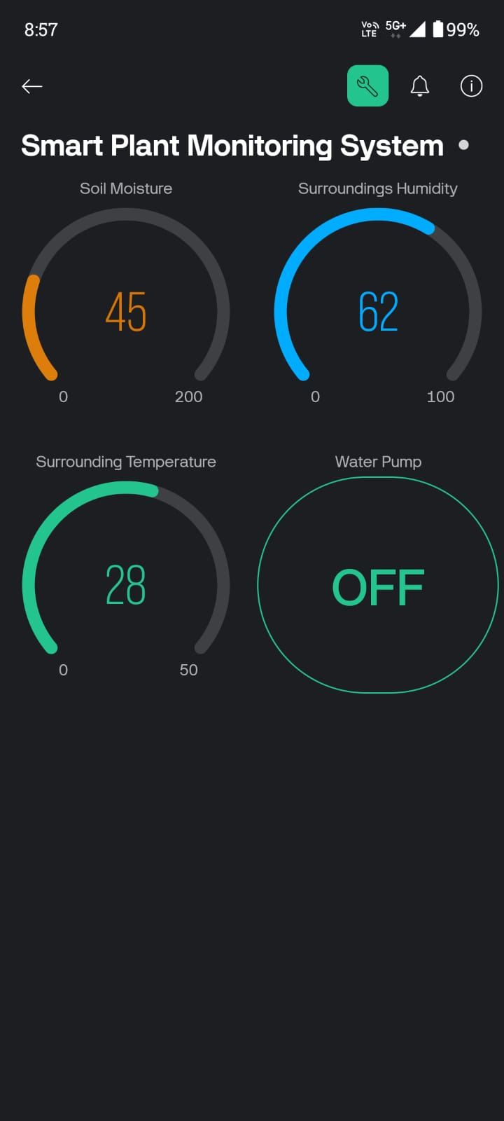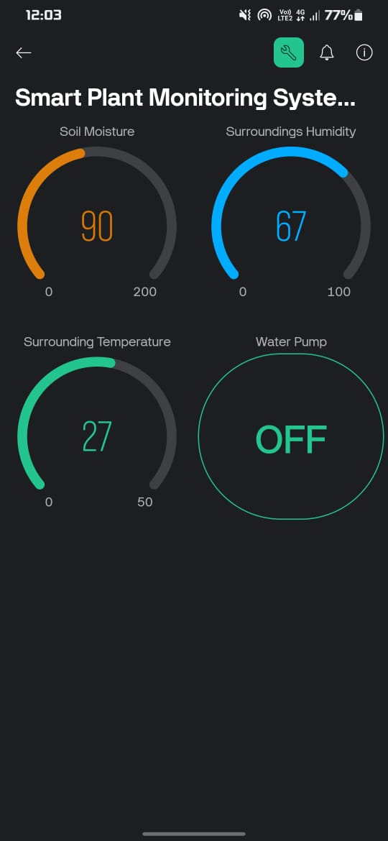
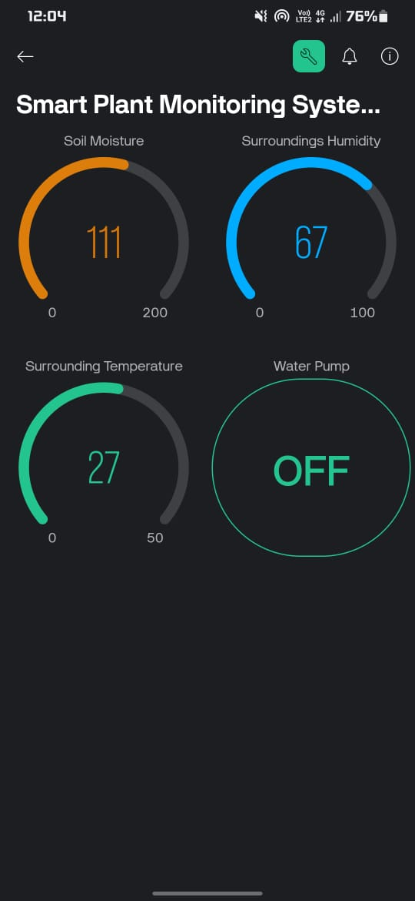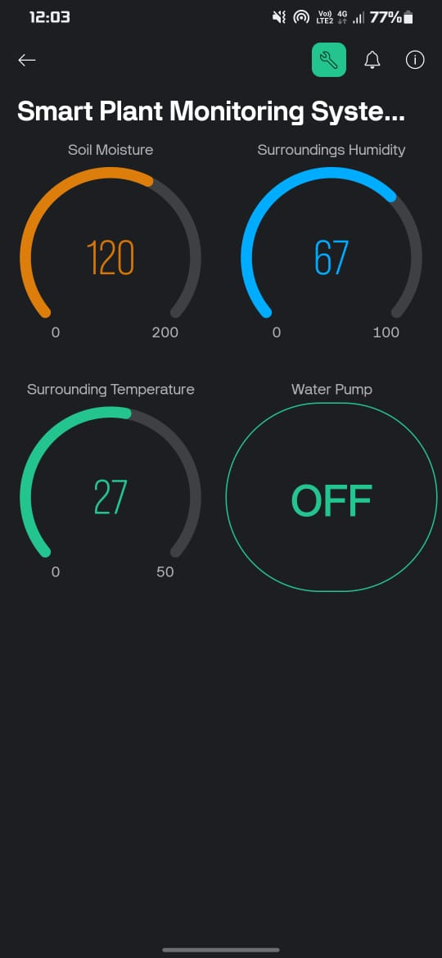
Figure 4.2.1

4.3 Conclusion
Smart plant monitoring systems built around the NodeMCU microcontroller and IoT principles offer a compelling solution for fostering healthier plants and promoting sustainable practices. By providing real-time data on crucial environmental factors like soil moisture, temperature, and humidity, these systems empower users to make informed decisions about plant care. The modularity of NodeMCU allows for customization to address specific needs, from monitoring rare plants in botanical gardens to ensuring the well-being of houseplants.
In conclusion, smart plant monitoring systems using NodeMCU represent a significant advancement in plant care. By offering data-driven insights and automation capabilities, these systems empower users to become better stewards of their plants, contributing to a greener future through efficient resource management and healthier plant life.
.4.4 Future Scope
The future of smart plant monitoring systems using NodeMCU and IoT holds exciting possibilities for even more advanced plant care and resource management. Here are some key areas of exploration:
Advanced Sensor Integration:
- Multi-parameter Sensors: Integrating sensors that measure light spectrum, nutrient levels, or even early signs of disease can provide a more comprehensive picture of plant health and potential issues.
- Image Recognition: Leveraging cameras and image recognition software could enable the system to identify pests or diseases visually, allowing for faster diagnoses and targeted interventions.
Machine Learning and Big Data Analytics:
- Predictive Analytics: Machine learning algorithms can analyze historical sensor data to predict potential problems like nutrient deficiencies or pest outbreaks before they occur.
- Personalized Plant Care: By learning about specific plant species and their unique needs, the system can offer personalized recommendations for watering, fertilization, and environmental adjustments.
Cloud-based Systems and Integration:
- Scalability and Remote Management: Cloud platforms can store and process data from numerous monitoring systems, enabling large-scale deployments and remote management of geographically dispersed plants.
- Integration with Smart Home Systems: Smart plant monitoring systems could be integrated with smart home systems, allowing for automated adjustments to lighting, temperature, or humidity based on real-time plant needs.
Advanced Automation and Robotics:
- Automated Nutrient Delivery: Systems could be designed to automatically adjust nutrient levels in hydroponic setups or deliver precise fertilizer doses based on sensor data.
- Robotic Plant Manipulation: Integration with robotic arms could enable tasks like automated pruning, weed removal, or plant relocation based on real-time monitoring data.
Sustainability and Resource Management:
- Water Conservation Techniques: Advanced systems could incorporate weather data and predict irrigation needs to optimize water usage and minimize waste.
- Integration with Sustainable Practices: The system could be linked to rainwater harvesting systems or utilize renewable energy sources for power, promoting sustainable plant care practices.
Accessibility and User-friendliness:
- Low-power Operation: Development of low-power NodeMCU variants or integration with energy harvesting techniques could extend battery life and reduce reliance on external power sources.
- Intuitive User Interfaces: Developing user-friendly interfaces with clear data visualization and actionable insights can make the technology more accessible to users with varying levels of technical expertise.
By exploring these advancements and tailoring the system to specific needs, NodeMCU-based smart plant monitoring systems have the potential to revolutionize plant care practices. They can lead to healthier plants, more efficient resource management, and a deeper understanding of plant science, fostering a future of sustainable and intelligent plant growth.

References
- Video Link: https: https://www.youtube.com/watch?v=MwIGkDKd3L4&list=LL
- Reference Link: Plant Monitoring and Control System | Nodemcu | Blynk | Monitor, and Water your plant from anywhere in the world – Techiqbal
- Lloret, J., et al. (2016). IoT-Based Smart Farming: A Framework for Soil Monitoring. Sensors, 16(5), 756.
- Mirás-Avalos, J. M., et al. (2019). IoT-Based Smart Irrigation Systems: An Overview on the Recent Trends on Sensors and IoT Systems for Irrigation. Sensors, 19(4), 809.
- Gope, P., et al. (2017). IoT-Based Smart Farming: A Survey. Journal of Agricultural Informatics, 8(1), 66-76.
- Zoha, A., et al. (2018). A Review on IoT-Enabled Real-Time Data Analytics in Smart Farming. Computers and Electronics in Agriculture, 151, 61-69.
- Bailey, D. G., et al. (2020). IoT-Based Smart Greenhouse: A Review. Sensors, 20(8), 2371.
- Karim, M. M., et al. (2021). IoT Applications in Agriculture: Current Status and Future Directions. Computers and Electronics in Agriculture, 190, 106442.

